l
MISSION
To provide a respite weekend in the Colorado Rockies for married couples that have experienced the death of a child.  VISION  “Praise be to the God and Father of our Lord Jesus Christ, the Father of compassion and the God of all comfort, who comforts us in all our troubles, so that we can comfort those in any trouble with the comfort we ourselves receive from God.”  2 Corinthians 1:3-4  contact information  Kelly Packard  Executive Director  PHONE: 765-717-3892  WEBSITE:  www.livinghopemountainrespite.com  EMAIL:  info@livinghopemountainrespite.com  FACEBOOK:  @livinghopemountainrespite  ADDRESS:  471 Ute Peak Drive  Livermore, Colorado 80536  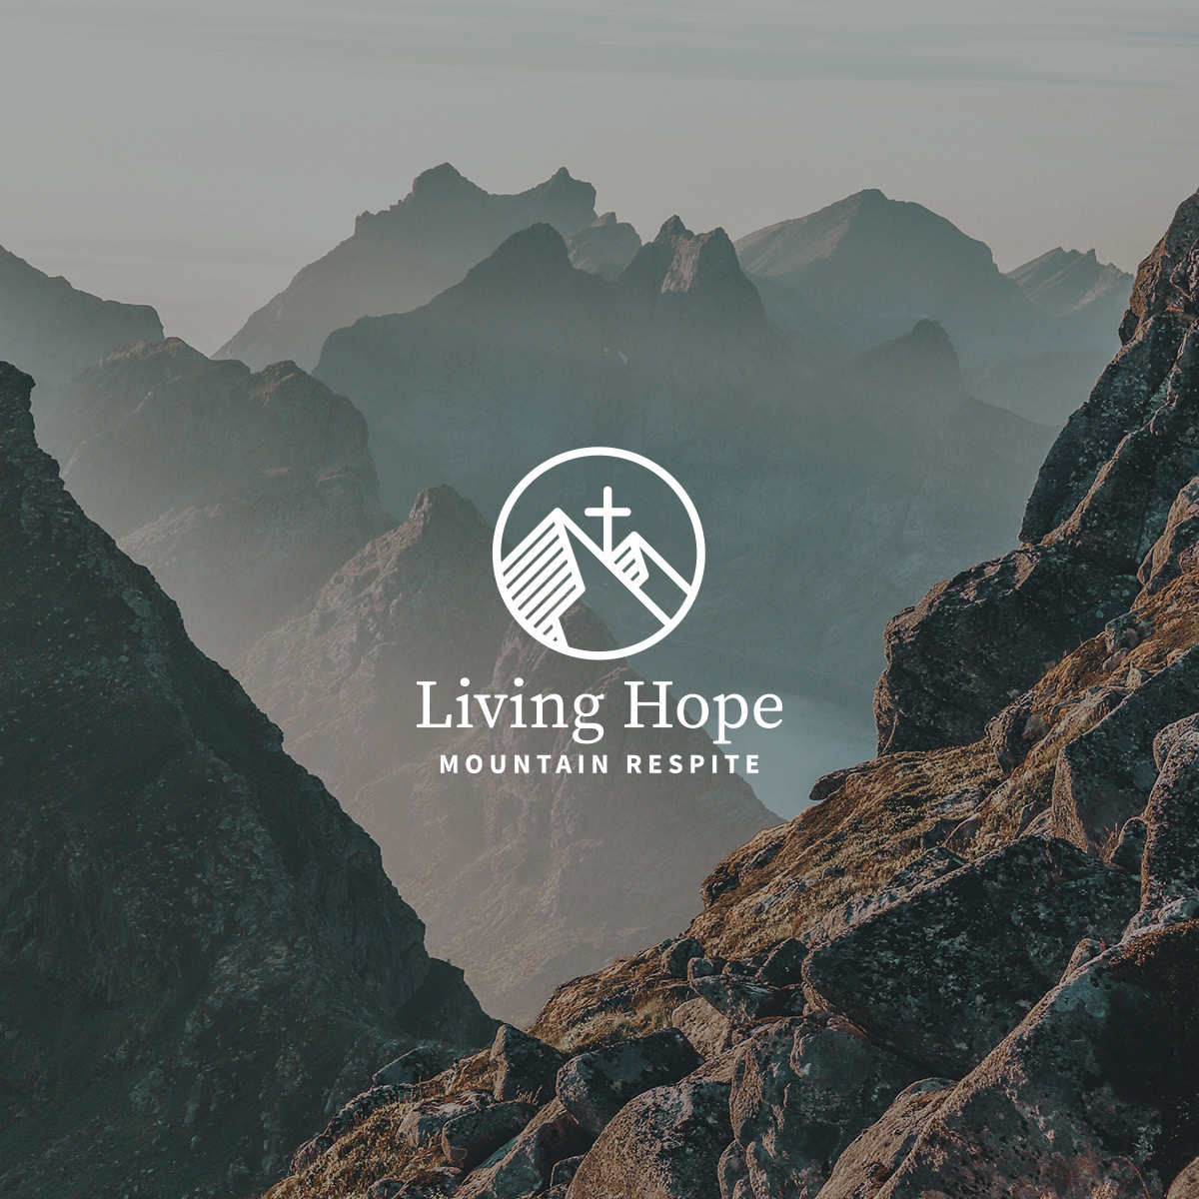 |  | fall 2023 ministry update  September 2023 Respite Retreat Highlights  What a weekend we shared together! It’s always incredible to see what happens when you invite the Holy Spirit to show up and take control. Hope overflowed from our Living Hope, Jesus Christ.  Just one small glimpse into the weekend...we discussed The Great Exchange. The Great Exchange is the daily exchange of despair for Hope by giving Jesus access to the pain and allowing His transformation power to author life-giving hope. This daily exchange of despair for hope creates a margin for the emotional capacity needed for a healthy marriage relationship.  We were humbled that this precious couple was courageously vulnerable to open sacred spaces of deep pain and share the raw reality of their brokenness, and to do so with two people they hadn’t truly met before.  No doubt, the Holy Spirit made this happen. We’re reminded of this truth from Zechariah 4:6 “...Not by might nor by power, but by My Spirit, says the Lord Almighty.”  We were honored to be able to come alongside this couple, if even for a weekend. As a result, they are preciously tucked inside our hearts.  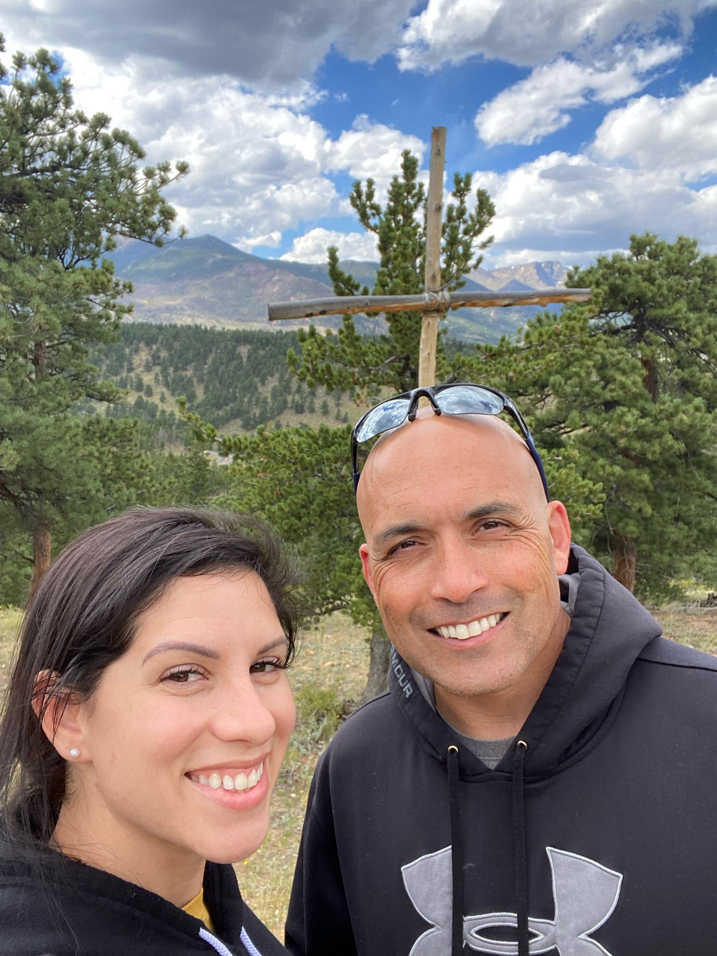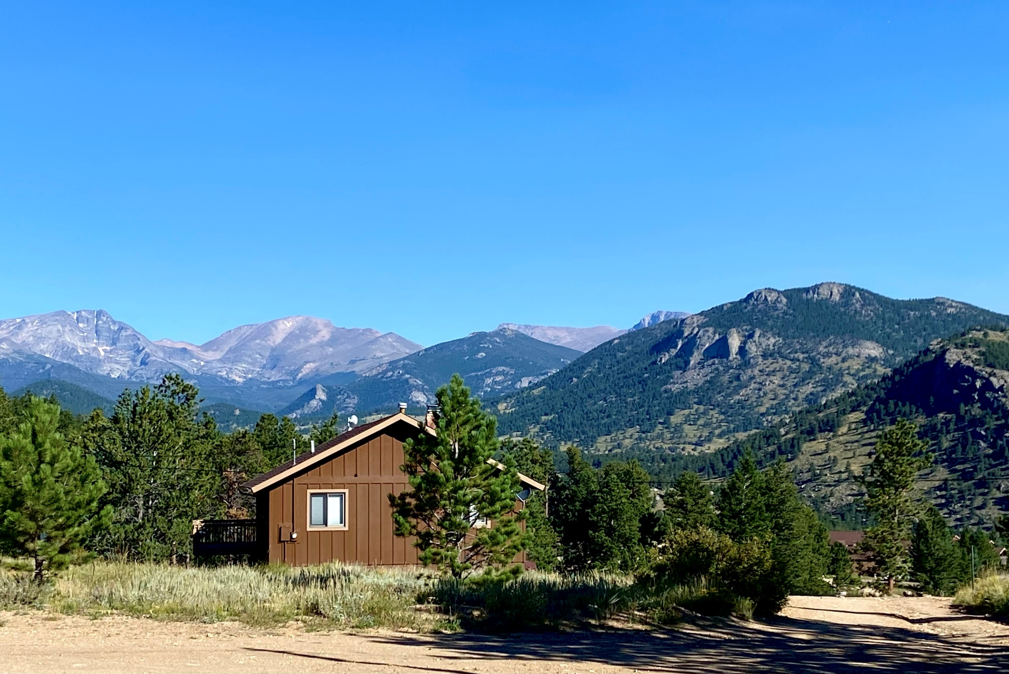  expanding grief-focused marriage ministry  Our mission states that we desire to provide a respite weekend in the Colorado Rockies for married couples that have experienced the death of a child. But what if health limitations prevent a couple from traveling? Thankfully, our desire to comfort others with the comfort we have received from God, and the content of the respite weekend CAN TRAVEL. In trust, we will be hosting our first mobile respite weekend in the home of a precious couple in January.  Living Hope Mountain respite Board of directors  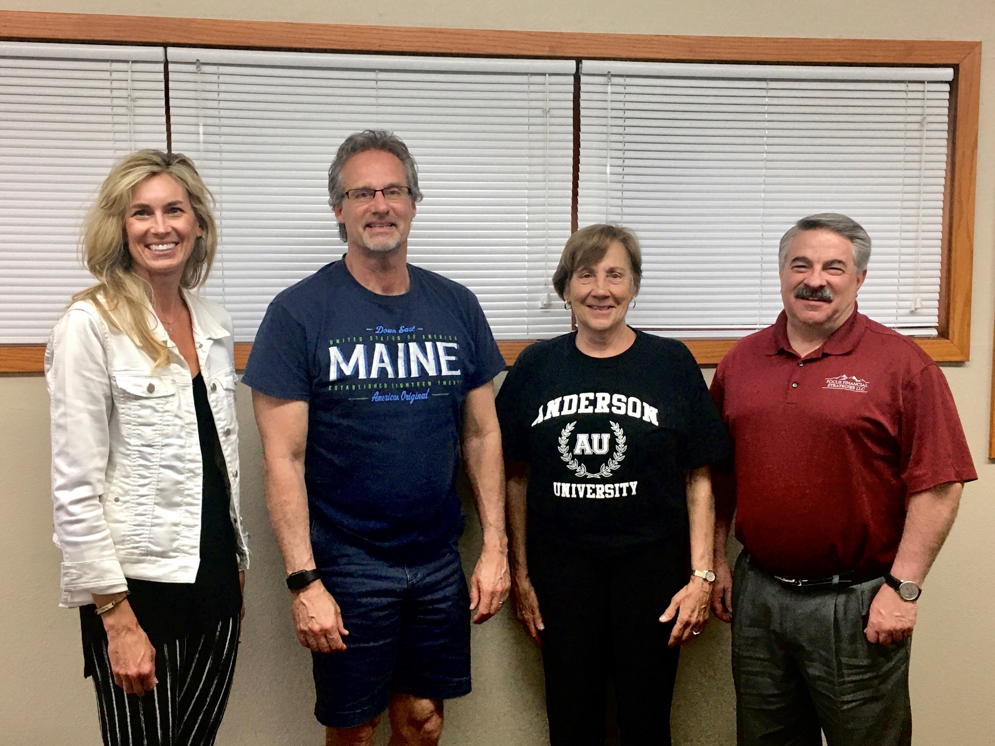  Kelly Packard, Kurt Anders, Alice Simpson, and Bill Hastings  Living Hope Mountain Respite launched as a nonprofit organization in April of 2020. The foundational years have been led by our inaugural Board of Directors (pictured above) with expertise and compassion to humbly serve and honor our mission and vision statement. Recently, each of our foundational board members acknowledged their desire to serve an additional 3-year term. Enjoy more details about our board on our website!  Featured Board Member Quote: God has guided the Packard’s to establish a respite weekend in a beautiful and peaceful location. You will be met with caring hearts and Godly encouragement as they share His amazing and steadfast love for you.”-Kurt Anders.  Giving Tuesday is November 28, 2023  Giving Tuesday is quickly approaching! This is Facebook’s annual fundraising event specifically for nonprofit organizations. Giving Tuesday is a significant annual financial provision for LHMR. We invite you to participate and share our social media posts if comfortable.  Year-End Giving  Keep Living Hope Mountain Respite in mind as you consider making end-of-year financial gifts. LHMR is a tax-exempt nonprofit ministry under Internal Revenue Code Section 501(c)(3).  Please also keep in mind any employer match programs. Our website provides various giving options.  prayer requests  - Our first mobile respite retreat, January 12-14, 2024  - For the development and growth of our relationships with the couples that have attended our respite retreats, our LHMR Alumni.

